**Week 05**

**Fetch**

Fetch is one way to request information or resources from the server and your return is a promise, this promise will verify the HTTP status and can return one response the success or reject. HTTP status 200 until 299 will return in successful response, reject will happen when having issues with the network or if the URL passed doesn't exist. For to do one request is need to set one URL and can put optional parameters, the basic syntax is below:



When optional parameters are not passed, a GET request takes place viewing the URL content, but to have access the content not just the head is necessary to call response method that can convert the content to some formats: text(), json(), formData(), bolb() and arrayBuffer(), below one example in .json()

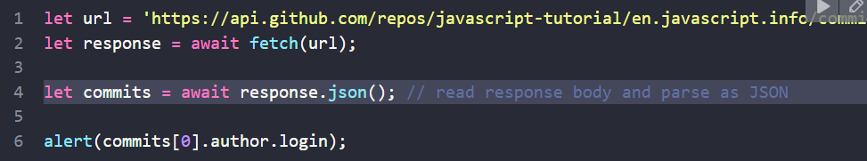

The other way, but the same result:

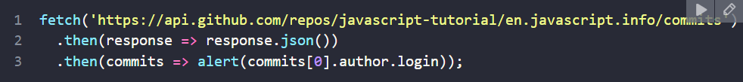

While the GET method receives information or resources, the POST method sends it and in the latter case the configuration is different in the fetch we need to declare the method, the head if it is not a string of characters and the body, below is an example using json:

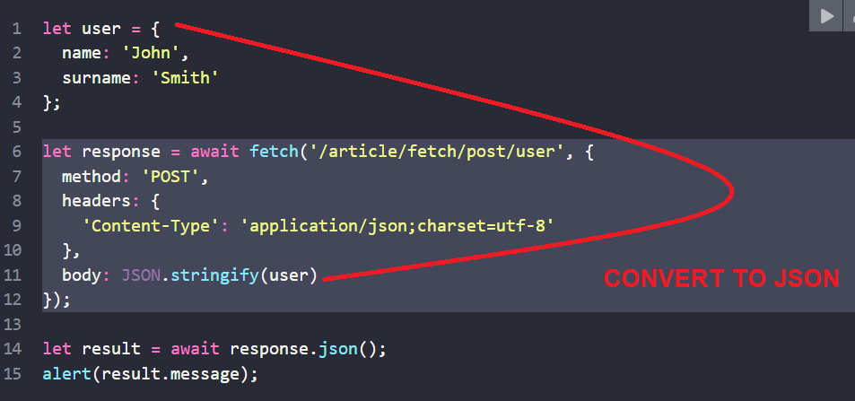

Interesting that fetch runs as if it were running in the "background" without stopping other script codes.

**CORS (Cross-origin Resource Sharing)**

Sometimes a web application needs to make a request for a domain other than its own, but in order to be successful in this request, the server needs to configure the header granting this permission. safer environment. It is possible to check header status in develop tools in network part, example:

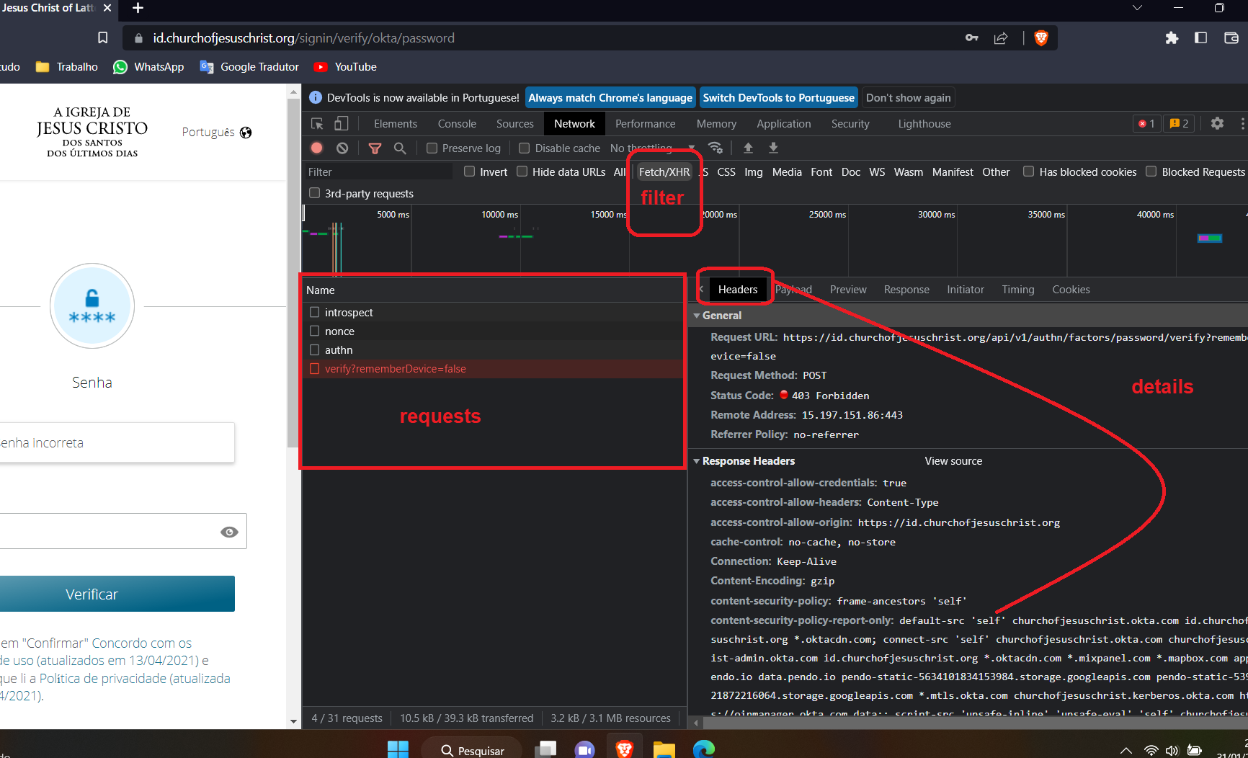

**Rest parameters and Spread**

Both using “...”, but when using the rest parameter in a function I allow the users to put how much parameters he wants, this way the parameters will be put one array, example:

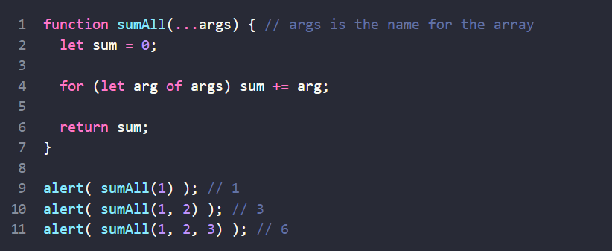

If the rest parameter is not used and more arguments are passed than defined in the function, an error will not occur, but only the number of parameters defined in the function will be executed.

The spread facilitates the access to the array for a function call or even to increase, concatenate or copy the array.

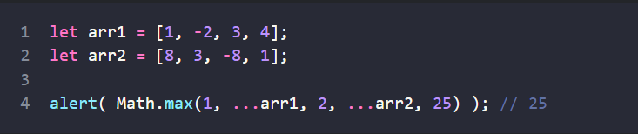

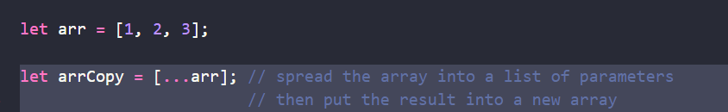

**Single-Page Application (SPA)**

This application is a way to gather all the pages into one, downloading all the content in the first request, in this way it keeps everything static and updates only the dynamic content, this through javascript. This way you can provide a better user experience, without having to make multiple requests to the server. If the content is very large, the first load will be slower, and using this architecture model you will have more difficulty with SEO because almost everything will be done in javascript, making indexing difficult because everything is done on the client side.